Quality and Outcomes Database (QOD)

QOD Quality Improvement Registry

User’s Manual: Statistics and Outcomes Report- Spine

November 27, 2018

Table of Contents

Table of Contents 2

Chapter 1: Purpose and Goal of the Statistics and Outcomes Manual 3

Chapter 2: The Statistics and Outcomes Report- Section I 4

2.1 Figure 1: Follow-up rate at 3 and 12-month post-surgery 4

2.2 Table 1: Frequency 4

Chapter 3: The Statistics and Outcomes Report- Section II 5

3.1 Table 2: Baseline characteristics for patients with follow-up 5

3.2 Table 3: Medical and clinical history for patients with follow-up 6

3.3 Table 4: Surgical procedures by diagnosis group for patients with follow-up 8

3.4 Table 5: Indicators of safety and quality of care for patients with follow-up 9

3.5 Figure 2: Satisfaction from surgery 10

3.6 Figure 3: Readmission category 10

3.7 Table 6: Utilization by surgical approach for patients with 3-month follow-up 11

Chapter 4: The Statistics and Outcomes Report- Section III 13

4.1 Table 7: Outcomes at baseline, 3-month and 12-month for patients with 12-month follow-up (overall) 13

4.2 Figure 4: Means and standard deviations at the three time points (NRS, ODI, and EQ-5D) 13

4.3 Table 8: Outcomes at baseline, 3-month and 12-month for patients with 12-month follow-up (by procedure) 15

4.4 Table 9: Site: Self benchmark patient reported outcomes and utilization 15

4.5 Figure 5: Site: Self-benchmark site mean vs risk adjusted QOD mean 16

4.6 Figure 6: Site: Self-benchmark return to work 17

# Chapter 1: Purpose and Goal of the Statistics and Outcomes Manual

The purpose of this manual is to explain how the Statistics and Outcomes Reports are generated and how to interpret them.

The QOD Statistics and Outcomes Report can be accessed through REDCap. The statistics provided are based on the number of patients with 3- and 12-month outcome data. Reports are not based on enrollment numbers. To ensure reliability and confidence in the findings, sites will not get an outcomes report or a physician report until the 3-month patient accrual exceeds 20 patients. This means that sites and physicians who have recently started enrolling patients will not yet have outcome reports.

The Statistic and Outcomes Reports include data from the date when the first patient was enrolled at the site to the date that data were downloaded for the current report. QOD total does include your site. They are uploaded to REDCap in April, July, October, and January.

# Chapter 2: The Statistics and Outcomes Report- Section I

The first section of the report contains follow-up rates, frequency data for 3 and 12-months, and number of patients included in this report for your site. These are shown in figure 1 and table 1.

## 2.1 Figure 1: Follow-up rate at 3 and 12-month post-surgery

This figure displays the follow-up rates for your site compared to the QOD total. This figure has a vertical red line at 80% follow-up rate. The goal for follow-up is 80% or above for all sites.

If your site has less than 20 patients at 12 month follow-up, your report will not include this figure.

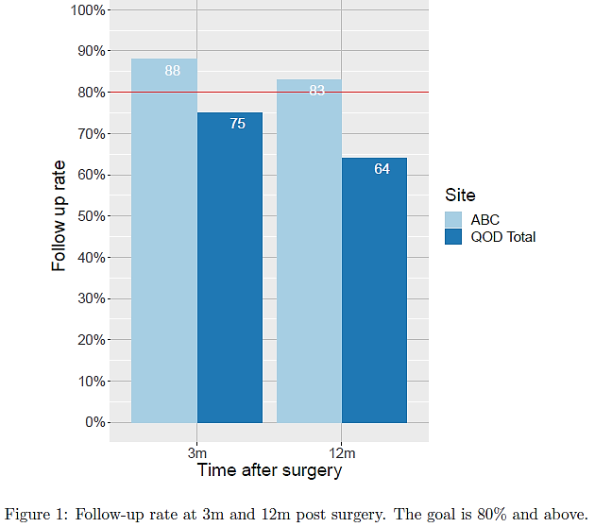

**How to interpret:** 88% of patients completed 3-month follow-up compared to 75% for the QOD total. 83% of patients completed 3-month follow-up compared to 64% for the QOD total

## 2.2 Table 1: Frequency

This table lists the number of surgeons, hospitals and the number patients with 3 and 12-month accrual. This also lists the total number of patients included in this report. This includes: 1) patients with 3 and 12-month follow-up, 2) patients who have 12-month follow-up but missed 3-month follow-up, 3) patients with 3-month follow-up and are not yet eligible for 12-month follow-up. The top row shows the numbers for all of QOD (including your site) and the second row shows your specific site accruals.

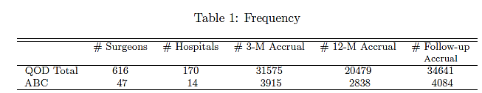

**How to interpret:** There is a total of 47 surgeons and 14 hospitals at ABC. The number of patients with baseline and 3-month data is 3915. This is regardless of whether they have 12-month data. The number of patients with baseline and 12-month data at this site is 2838. This is regardless of whether they have 3-month data. The total number of patients at your site included in this report (called “follow-up accrual”) is 4084. This includes: 1) patients with 3 and 12-month follow-up, 2) patients who have 12-month follow-up but missed 3-month follow-up, 3) patients with 3-month follow-up and are not yet eligible for 12-month follow-up.

# Chapter 3: The Statistics and Outcomes Report- Section II

The second section of the report contains patient characteristics, medical history, clinical variables, surgical procedures, indications for safety and quality of care, and utilization on patients with 3 and 12 month follow-up. These results are shown in tables 3-6 and figures 2-3.

## 3.1 Table 2: Baseline characteristics for patients with follow-up

This table provides a description of the patients in the database with accrual of 3 and 12 month outcomes. The table includes variables such as gender, age, education, employment, and insurance status. For categorical variables, such as gender, the proportion and frequencies are provided. The denominators indicate the number of patients with complete data for that specific variable. For continuous variables, such as age, the lower quartile, median, upper quartile are shown to the left outside of the parentheses. The mean and standard deviation are shown in the parentheses. N= number of patients included for that particular category.

The comparison between your site and all the other sites are made regarding each of the variables, and when the standardized difference is greater than 0.4, the variable will be highlighted in blue.

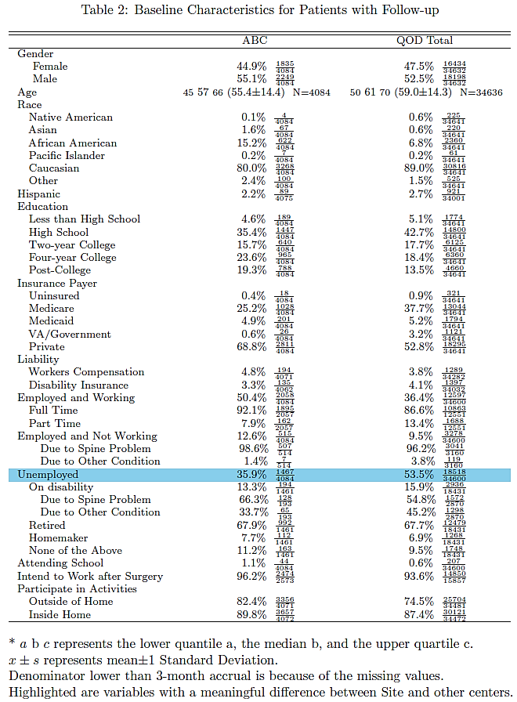

**How to interpret**: Of the 4,084 ABC patients included in this report, 1,835 (44.9%) are female, 2,049 (55.1%) are male, and 1,467 (35.9%) are unemployed. There is a meaningful difference in unemployment status between ABC and the QOD total and so it is highlighted in blue. The median age for ABC is 57 years old. 25% of the age values are ≤45 and 75% are ≤66 years old.

## 3.2 Table 3: Medical and clinical history for patients with follow-up

This table provides clinical history and surgical information. Lower quartile, median, upper quartile, mean and standard deviation are provided for continuous variables (e.g. BMI); proportion and frequencies are provided for categorical variables (e.g. smoking status and surgical approach). The denominators indicate the number of patients with complete data for that specific variable. The comparison between your site and all the other sites are made regarding each of the variables, and when the standardized difference is greater than 0.4, the variable is highlighted in blue.

**How to interpret**: Of the 4,083 ABC patients with comorbidity data, 611 (15%) are diabetic, 471 (11.5%) have a history of CAD, 4 (2.3%) have osteoporosis, 811 (19.9%) have a history of anxiety, and 806 (19.7%) have a history of depression. Of the 4,084 patients with a principal diagnosis,546 (%) have a diagnosis of spondylolisthesis, and 2,380 (58.3%) have a diagnosis of disc herniation. There is a meaningful difference in diagnosis of disc herniation between ABC and the QOD total and so is highlighted blue. The median BMI for ABC is 29.3 kg/m2. 25% of the BMI values are ≤25.8 kg/m2 and 75% are ≤33.6 kg/m2.

## 3.3 Table 4: Surgical procedures by diagnosis group for patients with follow-up

This table in lumbar provides surgical information by the principal diagnosis. In other words, surgery information is provided individually for patients with spondylolisthesis, disc herniation, stenosis, adjacent segment disease, and mechanical disc collapse, and pseudarthrosis. Proportion and frequencies are provided for categorical variables. The denominators indicate the number of patients with complete data for that specific variable. The comparison between your site and all the other sites are made regarding each of the variables, and when the standardized difference is greater than 0.4, the variable is highlighted in blue.

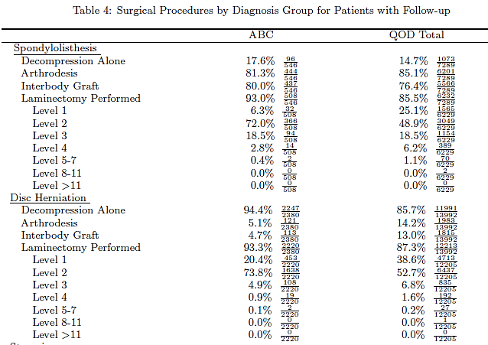

**How to interpret**: Of 546 patients who had spondylolisthesis selected, 96 (17.6%) had decompression alone, 444 (81.3%) had arthrodesis, 437 (80%) had an interbody graft, and 508 (93%) had a laminectomy performed. Of the 508 patients with laminectomy selected, 32 (6.3%) were performed at level 1, 366 (72%) were at level 2.

## 3.4 Table 5: Indicators of safety and quality of care for patients with follow-up

This table includes mortality, adverse events, patient satisfaction, and utilization. Lower quartile, median, upper quartile, mean and standard deviation for continuous variables; proportion and frequencies are provided for categorical variables. The denominators indicate the number of patients with complete data for that specific variable.

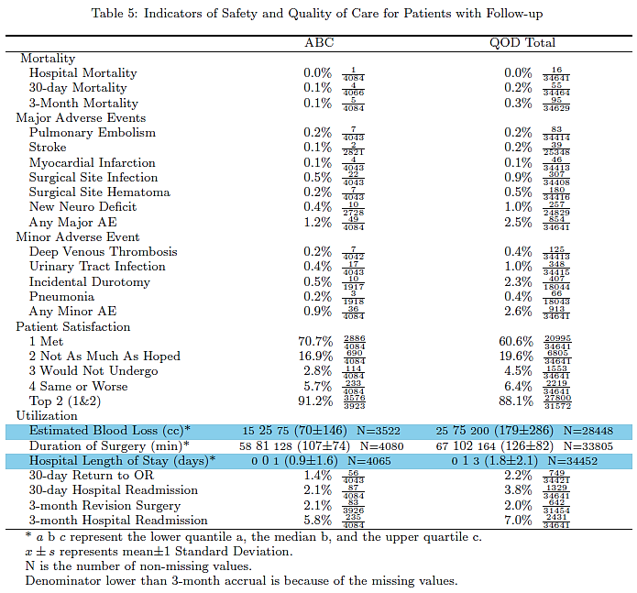

**How to interpret**: Of 4084 patients 1 died in hospital, 4 within 30 days, and 5 within 3-month after surgery. The median EBL for ABC is 25cc. 25% of the EBL values are ≤15cc and 75% are ≤75cc.

## 3.5 Figure 2: Satisfaction from surgery

This figure shows patient satisfaction rates from surgery for your site compared to the QOD total.

**How to interpret**: 17% of patients at ABC reported that they did not improve as much as they had hoped but would undergo the same operation for the same result compared to 20% of the QOD total. Overall 88% of patients at ABC were satisfied with their surgery.

## 3.6 Figure 3: Readmission category

This figure shows patient hospital readmission rates at 30-days and 3-months. Revision surgery at 3-months is also included in this figure.

**How to interpret**: 5.8% of patients at ABC had a readmission to hospital within 3-months of the surgery date compared to 7% of the QOD total.

## 3.7 Table 6: Utilization by surgical approach for patients with 3-month follow-up

In lumbar, the utilization results are presented for patients by surgical approach. Lower quartile, median, upper quartile, mean and standard deviation are provided for continuous variables; proportion and frequencies are provided for categorical variables. The denominators indicate the number of patients with complete data for that specific variable.

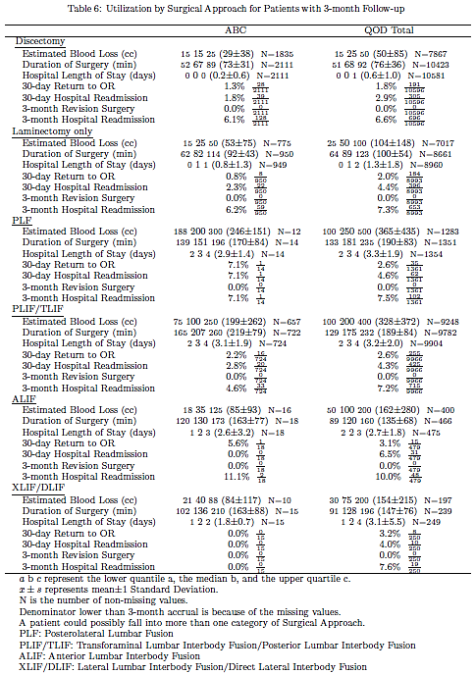

**How to interpret**: For patients who had a PLIF/TLIF, 657 had EBL values. The median EBL for ABC patients who received PLIF/TLIF is 100cc. 25% of the EBL values are ≤75cc and 75% are ≤250cc. Of 724 PLIF/TLIF patients, 16 (2.2%) returned to the OR within 30 days of their surgery date.

# Chapter 4: The Statistics and Outcomes Report- Section III

The third section of the report contains information on the patient outcomes. Results are shown in tables 7-9 and figures 4-6.

## 4.1 Table 7: Outcomes at baseline, 3 and 12-month for patients with 12-month follow-up (overall)

Pain, ODI and EQ-5D scores, return to activity and work, and patient satisfaction are presented in this table. Results are given at baseline, 3 and 12-month are included for patient reported outcomes. Lower quartile, median, upper quartile, mean and standard deviation are provided for continuous variables; proportion and frequencies are provided for categorical variables. The denominators indicate the number of patients with complete data for that specific variable. The sample size (N-B, N-3, and N-12) represents the number of patients with complete (non-missing) data. Return to work is a subgroup analysis. Results are only presented for patients who were employed during baseline and who indicated that they intended to return to work after surgery.

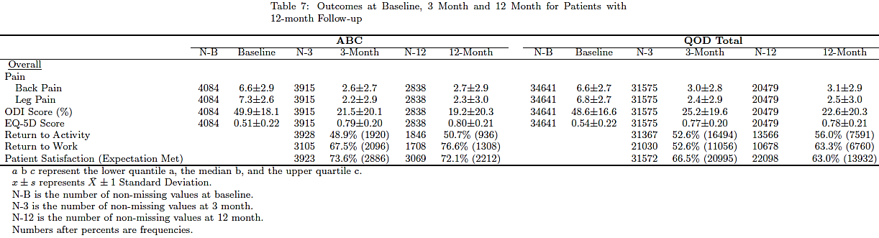

**How to interpret**: Back pain data was available for 4084 patients at baseline, 3915 at 3-month, and 2838 at 12-month for ABC overall. Average back pain is 6.6 at baseline, 2.6 at 3-month, and 2.7 at 12-month. Return to work data was available for 3105 patients at 3-month and 1708 at 12-month. Of these 2096 (67.5%) returned to work within 3 months of their surgery date and 1308 (76.6%) returned to work within 12 months of their surgery date.

## 4.2 Figure 4: Means and standard deviations at the three time points (NRS, ODI, and EQ-5D)

This figure shows the means and standard deviation (SD) at three time points (baseline and 3 and 12-month) for NRS-back/leg pain, ODI, and EQ-5D. The red dot indicates the mean for the QOD total and the blue star represents the mean for your site.

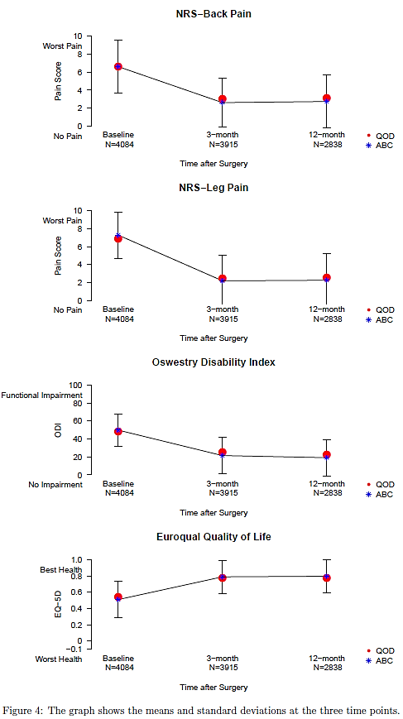

**How to interpret**: Average ODI score was ~50 at baseline, ~25 at 3-month, and ~20 at 12-month showing an improvement in functional impairment.

## 4.3 Table 8: Outcomes at baseline, 3-month and 12-month for patients with 12-month follow-up (by procedure)

This table is similar to table 7 but broken down by surgical procedures. Pain, ODI and EQ-5D scores, return to activity and work, and patient satisfaction are presented. Results are given at baseline, 3- and 12-month are included for patient reported outcomes. Lower quartile, median, upper quartile, mean and standard deviation are provided for continuous variables; proportion and frequencies are provided for categorical variables. The sample size (N-B, N-3, and N-12) represents the number of patients with complete (non-missing) data. Return to work is a subgroup analysis. Results are only presented for patients who were employed during baseline and who indicated that they intended to return to work after surgery.

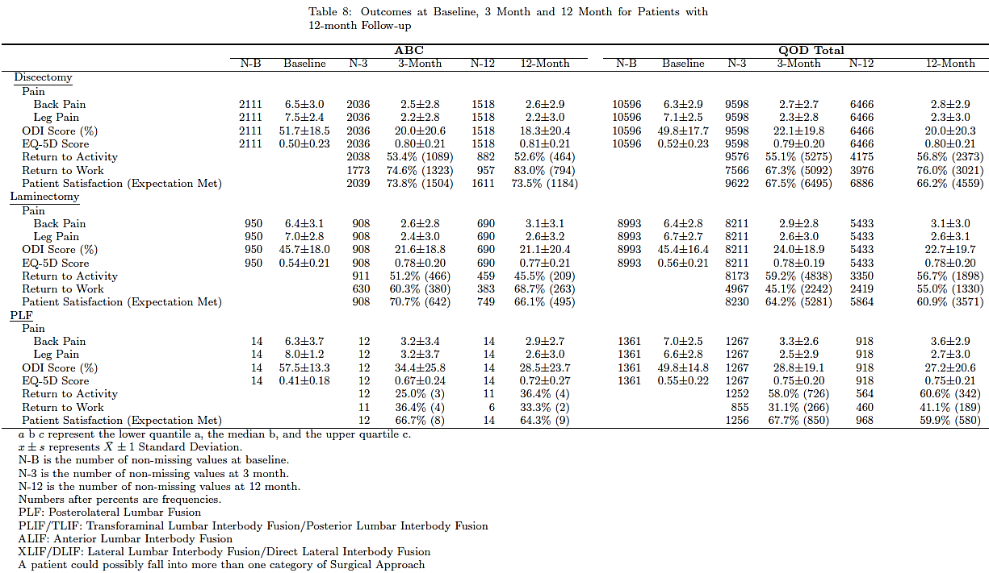

**How to interpret**: Back pain data was available for 2111 discectomy patients at baseline, 2036 at 3-month, and 1518 at 12-month for ABC. Average back pain is 6.5 at baseline, 2.5 at 3-month, and 2.6 at 12-month. Return to work data was available for 1773 patients at 3-month and 957 at 12-month. Of these 1323 (74.6%) returned to work within 3 months of their surgery date and 794 (83%) returned to work within 12 months of their surgery date.

## 4.4 Table 9: Site: Self benchmark patient reported outcomes and utilization

The table displays the site’s observed mean outcome (or average response to these outcomes) with 95% confidence interval and the sites expected mean. Results are given for 3 and 12-month outcomes. The expected mean for your site comes from a statistical model derived from the patient data from all the sites. This model also uses several of the variables from tables 1-6 to predict these outcomes. All results are adjusted for gender, age, race, ethnicity, education, workers compensation, liability claim, major surgery in the past, diabetes, CAD, osteoporosis, anxiety, depression, BMI, principal diagnosis, motor deficit, symptom duration, ASA grade, surgical approach, work, smoking status, and baseline scores. By comparing the observed site mean to the expected mean, each site can see how they are doing compared to QOD as a whole.

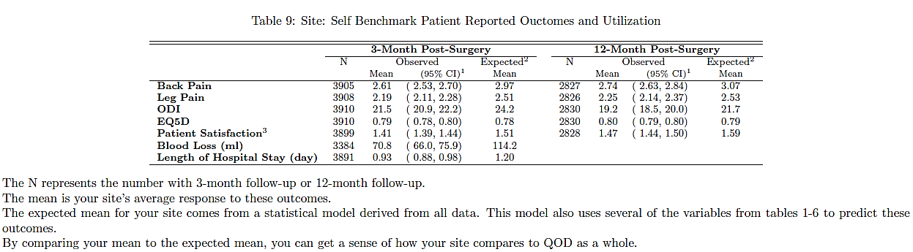

**How to interpret**: For 3910 ABC patients at 3 months, the average ODI score was 21.5 compared to the QOD average of 24.2.

## 4.5 Figure 5: Site: Self-benchmark site mean vs risk adjusted QOD mean

This Figure is a visual display of the results in Table 9. The solid blue circle is your site’s observed outcome; the solid red triangle is the expected outcome and indicates a statistical significant difference between your site and the QOD total; the green diamond is also a representation of the expected outcome but it is not statistically significant different from your site. The parentheses are the 95% confidence intervals of the observed mean. Your site is statistically significant different if the red triangle is outside the parenthesis.

**How to interpret**: At 3 months, the average ODI score was 21.5 compared to the QOD average of 24.2. For all outcomes presented in this figure, your site is significantly different than the QOD risk adjusted estimate (expected mean) at both 3 and 12-month timepoints. This is indicated by the red triangle appearance of the QOD risk adjusted value outside the parenthesis.

## 4.6 Figure 6: Site: Self-benchmark return to work

This figure shows the observed Return to Work for your practice group (black line) with 95% confidence interval, compared to the expected curve (blue line) based on a multivariable Cox proportional hazards model adjusting for the baseline characteristics. The vertical scale is probability of returning to work and the horizontal line is number of days after surgery. Controlling for patient characteristics, if the observed is above the expected, then the site’s

patients are returning to work sooner than expected based on QOD as a whole. If the observed is below the expected, then the site’s patients are returning to work later than expected based on QOD as a whole.

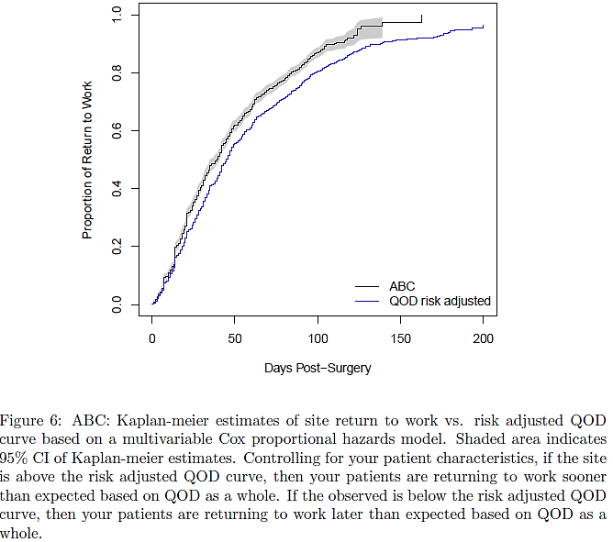

**How to interpret**: Patients at ABC are returning to work sooner than the expected based on QOD as a whole. This is indicated by observed black line being above the blue QOD risk adjusted curve.

**NOTE**: These findings are intended only for quality improvement. Site specific results will become more stable as sample size increases and data quality (completeness) improves. In addition, the multivariable model and methodology will become more refined over time.